Length: between 5,000 and 8,500 words, excluding references and annexes.

ARTICLE TITLE

ARTICLE TITLE IN ENGLISH

Name and two surnames of the first author (contact author): Affiliation, City, Country.
email@domain.com
https://orcid.org/xxxxxxx

Name and two surnames of the second author: Affiliation, City, Country.
email@domain.com
https://orcid.org/xxxxxxx

Additional subsequent authors in the same way...

If the article has funding, it goes here.
If you have placed your research data in a repository, you should mention it here (providing a brief description of the type of data deposited, the name and URL of the repository, the identifier code and the license and distribution details).
ABSTRACT (COMPULSORY)

Normal text... (Between 200 and 250 words)

Keywords: (compulsory)
Normal text; normal text. (7-9 words separated by semicolons, same characteristics as normal text)

ABSTRACT (COMPULSORY)

Normal text, normal text… (Between 200 and 250 words)

Keywords: (compulsory)
Normal text; normal text. (7-9 words separated by semicolons, same characteristics as normal text)
For Academic Projects and Contributions, some flexibility will be maintained in the headings, with only the INTRODUCTION, OBJECTIVES, CONCLUSIONS, REFERENCES and CURRICULUM being mandatory, and all others being subject to the author's discretion.
For Research Studies or Bibliographical Reviews, 7 headings numbered in Arabic numerals should be included. If you wish to add any more, it is best to do so as subheadings. The number of subheadings is not limited.

1. INTRODUCTION
2. OBJECTIVES
3. METHOD
4. RESULTS
5. DISCUSSION
6. CONCLUSIONS
REFERENCES

1. INTRODUCTION

Text containing section.

2. OBJECTIVES

Text containing section.

3. METHOD

Text containing section.

4. RESULTS

Text containing section.

5. DISCUSSION

Text containing section.

6. CONCLUSIONS

Text containing section.

Figure 1. Title of the figure

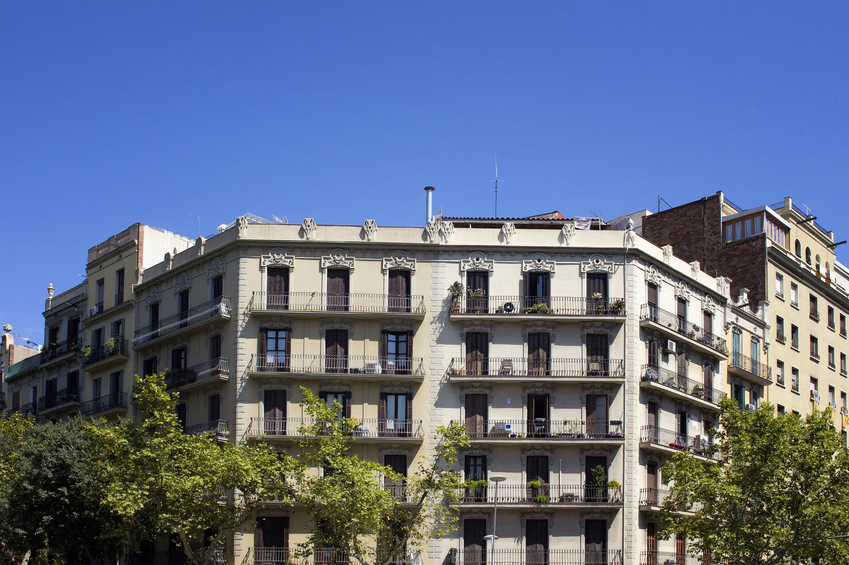

Source: text, text, text (compulsory).

Graph 1. Title of the graph

(The graph must be editable. It must be in image format, i. e., never send as PDF)
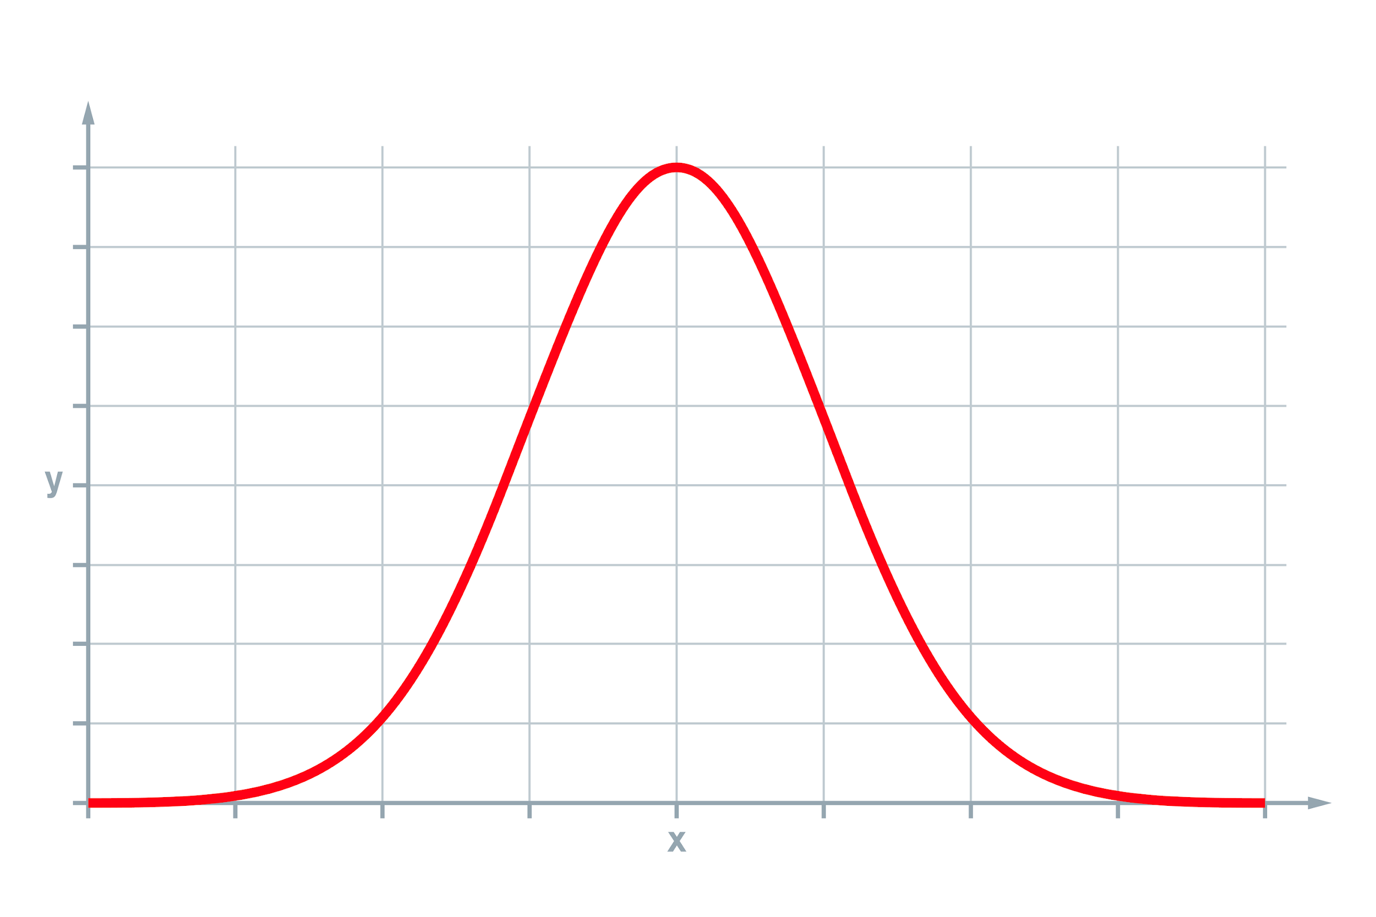
Source: text, text, text (compulsory).

Table 1. Title of the table

Header | Header | Header
Text in table | Text in table | Text in table
Source: text, text, text (compulsory).

1.1. Second level title (Arabic numerals)
Normal text; normal text...
1.1.1. Third and successive level titles (Arabic numerals)
Normal text, text...

NUMBERING WITHIN TEXT
The numbering within text (not the numbering of the headings) is also in Arabic numerals. They are not preceded by a blank space with respect to the preceding paragraph, but are followed by a blank space with respect to the following paragraph:
- First item of information.
- Second item of information.
- ...

Normal text...

CITATIONS:

Indirect or referential citation in normal text.
When paraphrasing or alluding to ideas from another work, the author and the year of the work should be placed in parentheses. It is recommended to indicate the page if the text from which the quotation is taken is long (Author, Year, p. xxx). If the paragraph includes the surname(s) of the author, only the date of the reference should be written in parentheses (Year). If the author is not cited in the paragraph, then the surname(s) and the date (Author, Year) should be written in parentheses. When the reference contains one or two authors, the surname(s) of both authors and the year (Author and Author, Year) should be written. If the reference contains more than two authors, only the surname(s) of the first author should be used, followed by et al. (Author et al., Year).

Text text text text text text text text text text text text text text text text text text text text text text text text text (Author and Author, Year, p. xxx-xxx) text text text text text text text.

Direct or textual citation within normal text (less than 40 words).
The text of the citation should be opened and closed with quotation marks. If the cited text reference has one or two authors, the surname(s) of both, the year and the page number(s) should be cited (Author and Author, Year, p. xxx). When the reference has more than two authors, only the surname(s) of the first author should be written, followed by et al., the year and the page (Author et al., Year, p. xxx).

Text text text text text text "text text text text text text text text text text text text text text text text text text text" (Author and Author, Year, p. xxx-xxx).

Direct or textual citation in normal text (more than 40 words).
If the citation is longer than 40 words, it should be written in a separate paragraph, without quotation marks and indented. At the end of the citation, the data of the reference should be included following these instructions: if the cited text has one or two authors, the surname(s) of both, the year and the page number(s) should be cited (Author and Author, Year, p. xxx). When there are more than two authors, only the surname(s) of the first author should be written, followed by et al., the year and page number(s) (Author et al., Year, p. xxx).

Text text text text text text text text text text text text text text text text text text text text text text text text text (Author and Author, Year, p. xxx-xxx).

REFERENCES

Bibliographic references should be included following the bibliographic style of the American Psychological Association (latest edition). All references, regardless of their type (book, article, thesis, etc.) must be included in alphabetical order by surname, without exception. Times New Roman 12, hanging indent 0.5 cm and justified. There should be a blank space between bibliographical references and the interlining should be simple. If the same author has more than one reference, his/her surname(s) should be rewritten, avoiding hyphens.

Examples:

Monographs (up to 20 authors, all surnames must be included) (print format)
Surname(s), N., Surname(s), N., Surname(s), N., Surname(s), N., Surname(s), N., Surname(s), N., Surname(s), N. and Surname(s). (Mention of responsibility). (Year of publication). Title: subtitle. (Edition number). Publisher.

Monographs (for more than 20 authors, the first 19 authors should be listed, three suspension points should be added and, finally, the last author) (printed format)
Surname(s), N., Surname(s), N., Surname(s), N., Surname(s), N., Surname(s), N., Surname(s), N., ... and Surname(s). (Mention of responsibility). (Year of publication). Title: subtitle. (Edition number). Publisher.

Monographs (up to 20 authors, all surnames must be included) (electronic format)
Surname(s), N., Surname(s), N., Surname(s), N., Surname(s), N., Surname(s), N., Surname(s), N. and Surname(s). (Mention of responsibility). (Year of publication). Title: subtitle. URL or DOI

Monographs (for more than 20 authors, the first 19 authors should be listed, three suspension points should be added and, finally, the last author) (electronic format)
Surname(s), N., Surname(s), N., Surname(s), N., Surname(s), N., Surname(s), N., Surname(s), N., Surname(s), N., ... and Surname(s), N. (Mention of responsibility). (Year of publication). Title: subtitle. URL or DOI

Book chapter (print format)
Surname(s), N., Surname(s), N. and Surname(s), N. (Year of publication). Title of the chapter. In N. Surname(s). (Mention of responsibility). Title: subtitle (ed. num., pp. 1-45). Publisher.

Book chapter (electronic format)
Surname(s), N., Surname(s), N. and Surname(s), N. (Year of publication). Title of the chapter. In N. Surname(s). (Mention of responsibility). Title: subtitle (ed. num., pp. 1-45). URL or DOI

Journal article (print version)
Surname(s), N., Surname(s), N. and Surname(s), N. (Year). Article title: subtitle. Journal name, volume (number), 1-45.

Journal article (electronic version)
Surname(s), N., Surname(s), N. and Surname(s), N. (Year). Article title: subtitle. Journal name, volume (number), 1-45. URL or DOI

Lectures, Conferences and Congresses
Surname(s), N. (Year). Title of the lecture, conference, seminar, etc. In N. Surname(s) (Mention of responsibility). Event title, Year (pp. 1-45). Publisher. URL

Surname(s), N. (Year). Title of the lecture, conference, seminar, etc. Event title. Place. URL

Surname(s), N. (Year). Part title. Event title. Place. URL

Doctoral thesis, academic works...
Surname(s), N. (Year). Thesis title (Doctoral thesis/Master’s thesis) URL

Laws
Full title of Act (BOE No. X, of day X of month X).

AUTHOR(S):

Name and complete surname(s) of the first author (contact author):
Summary of the author's curriculum vitae not exceeding 120 words. (single paragraph)
email@domain.com
https://orcid.org/xxxxxxx

Name and complete surname(s) of the second author:
Summary of the author's curriculum vitae not exceeding 120 words. (single paragraph)
email@domain.com
https://orcid.org/xxxxxxx

Subsequent authors in the same way...

Contribution of the author(s) to the work
The authorship roles should be identified in the following order, including the initials of each author in the corresponding task and omitting those roles that do not apply in each case. X. X. means the initials of the authors, and may include several authors for the same task.
Example: Idea, X. X.; Literature review (state of the art), X. X.; Methodology, X.X.; Data analysis, X. X.; Results, X. X.; Discussion and conclusions, X. X.; Writing (original draft), X. X.; Final revisions, X. X.; Project design and sponsorships, X. X.

APPENDICES/ANNEXES (optional, Times New Roman 12, bold, justified, single-spaced, with Arabic numerals)

